ROBERTSON, George Islay McNeill, British politician and tenth Secretary General of the North Atlantic Treaty Organization (NATO) 1999-2003, was born 12 April 1946 in Port Ellen, Isle of Islay, Scotland. He is the son of George Philip Robertson, policeman, and Marion MacNeill, teacher. On 1 June 1970 he married Sandra Wallace, with whom he has one daughter and two sons.
On 24 August 1999 Robertson was made a life peer as Baron Robertson of Port Ellen.

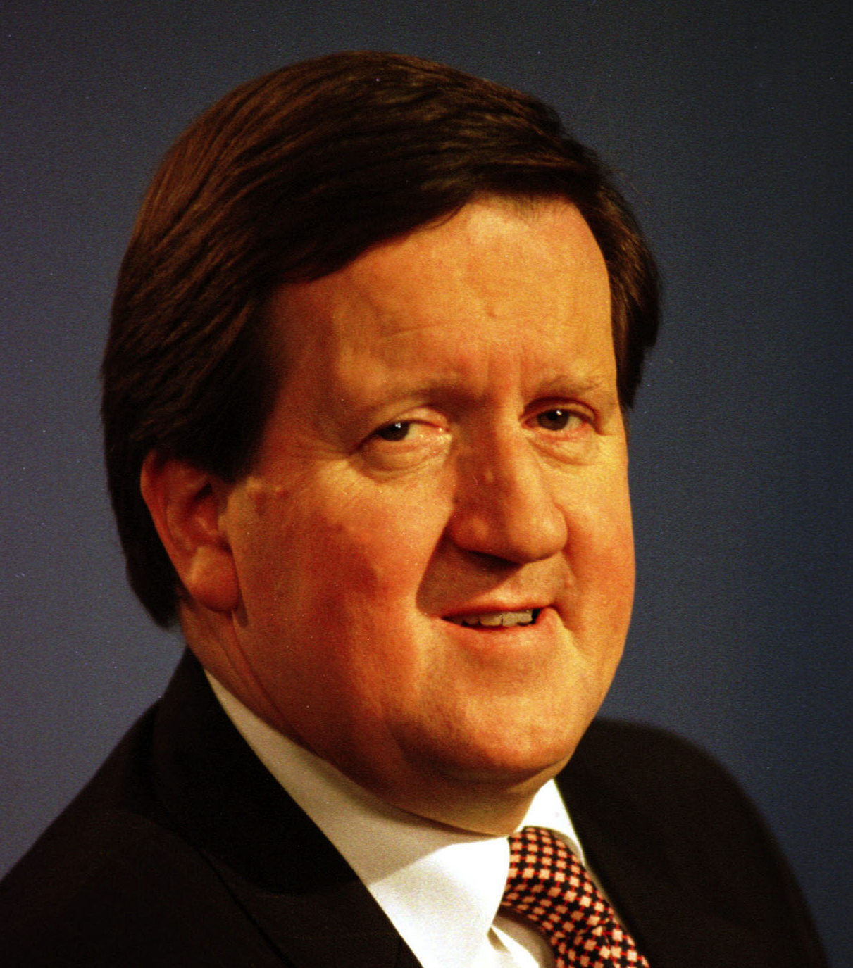
Source: Robertson, 14 October 1999, NATO
Video: www.youtube.com/watch?v=0Unmv3UilAQ,
www.youtube.com/watch?v=vDoc2ZJ3q60

Robertson’s father and grandfather were policemen, and his mother was a French language teacher. Robertson is thought to have been born in the Port Ellen police station and was educated at Dunoon Grammar School in Argyll. At the age of fifteen he became involved in politics by participating in protests against the docking of United States (US) nuclear Polaris submarines in Scotland. He studied economics at Queen’s College at the time when the college separated from the University of St. Andrews to become the University of Dundee, with Robertson one of the first students to graduate from Dundee with an honours Master’s degree in 1968. He wrote a column in the student newspaper Annasach and in 1968 he protested the government plan to lower student grants by organizing a 24-hour work session with other students in the university library. Following his graduation from university Robertson worked as a full time official for the General, Municipal and Boilermakers’ Union in the Scottish whisky industry from 1968 until 1978. In 1977 he survived a serious car crash, which caused damage to both of his knees and a broken jaw.
Between 1973 and 1979 Robertson chaired the Labour Party in Scotland. At the by-election in Hamilton in May 1978 he defeated his challenger with 51 per cent of the vote and was elected into the House of Commons. He was re-elected five times and remained in Parliament until 1997. In 1979 he was appointed Parliamentary Private Secretary to the Secretary of State for Social Services and later that year he became Opposition Spokesman on Scottish Affairs. Between 1982 and 1993 he was Opposition Spokesman on Defence and Foreign Affairs and also on European Affairs between 1983 and 1993. In 1993 he was named Joint Parliamentarian of the Year for his role during the ratification of the Treaty on European Union in Maastricht. In that year he became Shadow Secretary of State for Scotland and in May 1997 he was appointed a Member of the Privy Council, a formal body of advisers to the Queen. In March 1996 a gunman murdered 16 young children and their teacher at the Dunblane School before killing himself. Robertson, whose children were graduates of that school, became a spokesman for the victims’ families and a key political figure in the campaign that led to a ban on personal handguns in the United Kingdom (UK) under the Conservative government of John Major. The 1997 general elections brought the Labour Party into power, with Tony Blair becoming Prime Minister. Given Robertson’s understanding of defence and international security topics, Blair appointed him as Secretary of Defence.
When the time came to look for a new Secretary General of the North Atlantic Treaty Organization (NATO) in late summer of 1999, the British put forth Robertson’s name. In his public speeches before becoming NATO Secretary General, Robertson defended the alliance and opposed unilateral disarmament, even at the time when the Labour Party advocated this position. As British Defence Secretary he favoured NATO’s bombing of Yugoslavia during the Kosovo conflict of early 1999, with the UK military contribution on the ground in Kosovo being the largest among the European allies. Other candidates were former Belgian Prime Minister Jean-Luc Dehaene, Danish Defence Minister Hans Haekkerup and also German Defence Minister Rudolf Scharping, known for his in-depth reform of the German Bundeswehr armed forces. Scharping, however, withdrew as he was too deeply involved in Germany’s military reform, which paved the way for the designation of Robertson as NATO’s next Secretary General. Along with backing from Blair, Robertson also won the support of the US administration under President William Clinton and from European partners such as France, Italy and Spain. This wide support gave Robertson political credibility as he was elected NATO Secretary General on 4 August 1999. On 14 October he took up his duties as successor of Javier Solana de Madariaga, who like Robertson had been an anti-nuclear and anti-US protester in his youth.
Robertson’s experience as UK Secretary of Defence, as well as being a prominent member of the Council of the Royal Institute of International Affairs, gave him a clear policy priority when he came to NATO headquarters in Brussels to take over as Secretary General. Based on the experience of the Balkan Wars (NATO had been involved in Bosnia and Herzegovina since 1992 and in Kosovo since 1999), he believed that NATO should remain relevant for meeting the security challenges of the post-Cold War era. From the beginning of his time in office Robertson had to solve problems stemming from NATO’s interventions in such conflicts, particularly European reservations with regard to contributing to NATO actions. In 1999 the Stabilization Force in Bosnia and Herzegovina counted 12,000 soldiers. This operation was deployed by NATO from December 1996 to December 2004 under a United Nations (UN) mandate in order to improve security and help rebuild the country after the war. The Kosovo Force, deployed in June 1999 with the task of stopping the Kosovo conflict, under a UN mandate launched after 78 days of bombing Serbian positions, involved over 46,000 soldiers. When Macedonian Albanians started military assaults against the Macedonian government in 2001, Robertson launched a third NATO operation, named Essential Harvest. Robertson used his diplomatic experience during negotiations and played an active role in ending violence in Macedonia. Given his efforts to strengthen the ties between both sides of the Atlantic, he succeeded in developing a high level of trust and mutual understanding with the US administration, both under President Clinton and President George W. Bush, which resulted in greater room for manoeuvre as Secretary General.
Robertson experienced an intense mandate as Secretary General, with major events including the 11 September 2001 attacks on the World Trade Center in New York by al-Qaeda, the start of the war against the Taliban in Afghanistan in October 2001 and the launching of the war against Saddam Hussein’s Iraq in March 2003. The terror attacks of 2001 opened a new era for NATO. Article 5 of the North Atlantic Treaty, which regards an attack on one member as an attack on all, was invoked in support of the US. Although the US government did not invoke Article 5 at first, NATO ambassadors met immediately after the attacks, with Robertson firmly advocating in favour of enacting the article. He also reached out to convince reluctant heads of state and foreign ministers over personal phone calls. Former US NATO ambassador Nicholas Burns underlines that Robertson ‘shepherded the Alliance’s first-ever invocation of Article 5’ (Hendrickson 2006: 121).
The terror attacks of 2001 also created conditions for Robertson to promote the transformation of NATO in order to cope with new international security challenges. As British Defence Secretary he had advocated modernization of British armed forces and, from the NATO Summit in Prague in November 2002 where seven Central and Eastern European states were invited to begin accession talks with NATO, he emphasized that all member states should improve their national military capabilities and increase their defence budgets. Member states should also transform their armed forces in order to be able to intervene collectively in more diverse missions. His mantra became ‘capabilities, capabilities, capabilities’ (Hendrickson 2006: 121). His proactive position fitted the US demand for a more equitable burden sharing among the members of the alliance, but also pushed forward the promotion of stronger European military capabilities, which was in line with French and German initiatives under the European Security and Defence Policy framework. Thanks to Robertson’s dedication, diplomatic qualities and political lobbying (sometimes rumoured to be ‘aggressive’, according to Hendrickson 2006: 123), in November 2002 NATO agreed on the Prague Capabilities Initiative which called for increasing defence expenditures by all NATO member states and for the creation of a NATO Response Force capable of rapid deployment to meet new security challenges. By advocating more and renewed capabilities, Robertson attempted to shift the nature of the alliance towards a more global security organization instead of one dedicated only to European territorial defence. This changing nature of NATO was backed up by the inclusion of new Central and Eastern European member states. Robertson played an active diplomatic role to convince existing NATO members to invite seven countries from the former Soviet bloc (Bulgaria, Estonia, Latvia, Lithuania, Romania, Slovakia and Slovenia) to join in the near future. He also convinced countries to undertake troop operations in the International Security Assistance Force (ISAF) in Afghanistan, established by the UN Security Council in December 2001 to train Afghan troops and assist the Afghan government. The NATO-led ISAF mission increased over time and became NATO’s largest operation ever, counting 130,000 military personnel in August 2003.
Robertson’s tenure as Secretary General also faced difficulties related to two main tensions between 2001 and 2003. One was the general US distancing from NATO under President Bush and another was the growing divide between the US and the European member states, as well as schisms among European countries, over the issue of the invasion of Iraq in 2002-2003. In spite of the successful invocation of Article 5, the US administration did not envisage a leading role for NATO in operation Enduring Freedom, which was launched by the US government in Afghanistan in October 2001. NATO provided seven Airborne Warning and Control Systems Aircrafts for the operation, but otherwise played only a limited supporting role during the first months of the US ‘war on terror’, as it was called. Robertson, however, never stopped advocating for closer ties between the US and Europe through NATO, seeking to affirm the community of values shared by both sides of the Atlantic. As Secretary General he supported complementarity between NATO and the European Union (EU) and in December 2002 he saw the Berlin Plus Agreements being signed. This package of seven agreements was derived from the April 1999 NATO Summit in Washington DC and finalized between Robertson on behalf of NATO and Solana as EU High Commissioner for Foreign Affairs and Security Policy in March 2003, enabling the EU to use NATO assets and capabilities for EU-led crisis management operations. In 2000 Robertson estimated that the US ‘suffered from a sort of schizophrenia’ where European defence was concerned (quoted in Cornish and Edwards 2001: 592), but his diplomatic rhetoric in favour of an EU-NATO relationship contrasted with the growing feeling of distance between the US and European countries such as France and Germany, even before the trans-Atlantic divide over the Iraq issue of 2002. Robertson did not succeed in narrowing the gap between the Bush administration and major European NATO member states. The dispute resulted in the stigmatization of an ‘old Europe’ of countries that had serious doubts about raising the issue regarding Iraq’s Saddam Hussein to the military level and a ‘new Europe’ of countries that were ready to follow the US and intervene in Iraq. This tense episode of NATO’s post-Cold War years suggest that a Secretary General, whatever political credibility and legitimacy he possesses, cannot do much when political divisions are as deep as they were over the invasion of Iraq in 2003. In 2002 and early 2003 Robertson could only act with caution to keep the Alliance together. In his public speeches he therefore refrained as much as possible from talking about Iraq. He instead focused on NATO’s relevance after the 2001 terror attacks and the fight against international terrorism or he spoke about NATO’s necessary transformation in order to act more efficiently and rebalance the burden sharing in terms of military expenditures and capabilities.
The invocation of the rarely used Article 4 of the North Atlantic Treaty was another case where Robertson faced limits. This article calls for consultation when a member state’s independence or security is threatened, with the idea that it should be used only to send a strong political signal that NATO is concerned about a particular situation. The US government officially requested consultation on Iraq and NATO’s support of possible US intervention in January 2003. Robertson actively supported the US request and discussed US military proposals to use NATO bases to help secure Turkey, if necessary, and to get European member states more involved in NATO’s military operations in the Balkans to replace some of the US troops which could then be deployed in Iraq. Robertson advocated the US position vis-à-vis the European member states and used the consultation process related to Article 4 to reach a collective agreement. He even used NATO’s informal silence procedure, in which the Secretary General sets a specific amount of time to come to a collective agreement. If the silence is not broken during this time period, then the Secretary General’s policy proposals are considered to be adopted and consensus reached. This diplomatic tactic is used when one or more states do not completely agree with NATO’s collective proposals but do not want to obstruct further collective action. Robertson’s use of this procedure soon revealed an internal crisis because France and Germany broke their silence. The consequences were increased tensions and invocation of Article 4. Turkey requested that NATO defend Turkey if needed in the case of war with Iraq. To overcome the divide, Robertson chose to move the discussion to another NATO organ, the Defence Planning Committee, in which France was absent since the decision of General Charles de Gaulle in 1966 to withdraw France from NATO’s military command. The decision to change the negotiation forum shows that the Secretary General has some independence in situations requiring the maintenance of negotiations. As a result, however, Robertson found himself between the US and Belgium, represented by ambassador Dominique Struye de Swieland, who opposed the Article 4 application. Robertson strongly lobbied in favour of the US position on the Iraq issue and the Turkish request for security and used the argument of alliance solidarity to convince member states. A compromise reached in February 2003 referenced UN purposes, coupled with wordings about limited defensive NATO measures. In sum, Robertson could exert his leadership because of his good relationship with the US administration, but even with consensus ultimately reached, his intense application of pressure also exacerbated the crisis within NATO, particularly with France and Germany.
When looking at Robertson’s functioning within NATO’s bureaucracy, his role as Chairman of the North Atlantic Council (NAC) was active, with commitment and an excellent knowledge of defence issues. Ambassadors to NATO also pointed to his sense of humour during tense discussions. His main disadvantage as Chairman of the NAC was his incompetence in French, in spite of his mother being a French language teacher. English and French are NATO’s two official languages and not mastering both, especially during the moment of crisis over the Iraq issue, impeded the ability to smooth his dialogue with France and Belgium. Robertson furthermore clashed with Benoît d’Abboville, the French Ambassador to NATO, both politically and personally, given d’Abboville’s known difficult personality (Segell 2004: 155). Robertson worked closely with Joseph Ralston, the Supreme Allied Commander Europe. Their working relationship was effective, conducted via a weekly Tuesday videoconference. Ralston kept Robertson regularly informed about important US diplomatic and military initiatives. Robertson’s understanding of the Bush administration and his use of humour gave him a potential for leadership that only a close connection and a mutual trust with the US could provide in those turbulent times. Robertson’s most important assets probably were his excellent knowledge of the issues at stake and his strong commitment to the Atlantic connection. In November 2003 President Bush awarded Robertson with the US Presidential Medal of Freedom, the US highest civilian honour, which is rarely bestowed upon foreign nationals.
Robertson’s tenure as Secretary General of NATO concluded on 16 December 2003, with Acting Secretary General Alessandro Minuto-Rizzo of Italy in place until 5 January 2004 at which time Jaap de Hoop Scheffer of the Netherlands took up his duties as Secretary General. Robertson soon returned to the UK, was named a life peer as Baron Robertson of Port Ellen in 1999 and subsequently elevated to the House of Lords. He served two terms as President of the Royal Institute of International Affairs (between 2002 and 2012) and took a series of boardroom roles, holding deputy directorships of several notable companies in the UK, including the Weir Group, Cable and Wireless PLC (2004-2006) and TNK-BP (2006-2013). Robertson also became Senior Counselor at The Cohen Group in Washington DC, founded by William Cohen, Secretary of Defence in the Clinton administration, to provide advice and assistance in marketing and regulatory affairs. In February 2009 Robertson gave a speech on the occasion of NATO’s sixtieth birthday, in which he underlined how relevant NATO still was and how the organization had transformed during the two last decades to cope with transnational threats characterizing international security after the Cold War. He is a member of the Top Level Group of UK Parliamentarians for Multilateral Nuclear Disarmament and Non-Proliferation. Robertson was strongly engaged in the 2014 Scottish referendum campaign as a proponent for Scotland remaining within the UK. In 2017 he declared that Scottish independence would strengthen terrorist groups and that he is a strong supporter of the UK’s integrity (MacMahon 2017).

PUBLICATIONS: ‘Britain in the New Europe’ in International Affairs, 66/4, 1990, 697-710; ‘The Commonwealth: Forum for Debate or Concert for Action?’ in The Round Table, nr. 315, 1990, 268-274; ‘Sécurité et interdépendance’ in Politique étrangère, 1999/4, 863-866; ‘“Rebalancing NATO for a Strong Future”. Remarks at the Defence Week Conference, Brussels, Belgium, 31 January 2000, available at www.nato.int/docu/speech/2000/s000131a.htm; ‘NATO and Its Neighbours to the East’ in International Relations: The Journal of the David Davies Memorial Institute of International Studies, 15/4, 2001, 5-9; ‘NATO in the 21st Century’ in Hampton Roads International Security Quarterly, 30 March 2002, 8-13; ‘NATO and the Transatlantic Community: The “Continuous Creation”’ in Journal of Transatlantic Studies, 1/1, 2003, 1-7; ‘The Safety of the Realm in Retrospect and Prospect: NATO & Mediterranean Security: Practical Steps towards Partnership’ in The RUSI Journal, 2003, 148/4, 50-52; ‘A Vibrant and Flexible Alliance’ in Politique étrangère, 2009/5, 15-23; ‘Remarks by Former NATO Secretary General Lord Robertson’, 25 February 2009, available at: www.cfr.org/event/nato-60-symposium-remarks-former-nato-secretary-general-lord-robertson.
LITERATURE: P. Cornish and G. Edwards, ‘Beyond the EU/NATO Dichotomy: The Beginnings of a European Strategic Culture’ in International Affairs, 77/3, 2001, 587-603; P. Gordon, ‘NATO after 11 September’ in Survival, 43/4, 2001, 89-106; interview in Los Angeles Times, 15 April 2001, available at http://articles.latimes.com/2001/apr/15/opinion/op-51153; S. Croft, ‘Guaranteeing Europe’s Security? Enlarging NATO Again’ in International Affairs, 78/1, 1 January 2002, 97-114; interview at NPR News, 20 February 2003, available at www.npr.org/programs/atc/transcripts/2003/feb/030220.norris.html; P. Gallis, ‘NATO’s Decision-Making Procedure’ in CRS Report for Congress, 5 May 2003; interview at BBC News, 26 November 2003, available at http://news.bbc.co.uk/2/hi/programmes/newsnight/3236374.stm; Z. Barany, The Future of NATO Expansion: Four Case Studies, Cambridge 2003; G. Segell, Disarming Iraq, New York 2004; D. Leigh and R. Evans, ‘From Brussels to the Boardroom: What Robertson Did Next’ in The Guardian, 9 February 2006, available at: www.theguardian.com/news/2006/feb/09/freedomofinformation; R.C. Hendrickson, Diplomacy and War at NATO: The Secretary General and Military Action after the Cold War, Columbia 2006; R. Rupp, NATO after 9/11: An Alliance in Continuing Decline, New York 2006; K. Baxter, M. Rolfe and D. Swinfen, A Dundee Celebration, Dundee 2007; G. Aybet and R.R. Moore (Eds), NATO in Search of a Vision, Washington DC 2010; L.S. Kaplan, NATO and the UN: A Peculiar Relationship, Columbia 2010; O. Kempf, L’OTAN au XXIème siècle. La transformation d’un héritage, Paris 2015; J. Lindley-French, The North Atlantic Treaty Organization: The Enduring Alliance, London 2015; H. Dijkstra, International Organizations and Military Affairs, London 2016; P. MacMahon, interview at ITV, 5 September 2017, available at www.itv.com/news/border/2017-09-05/independence-would-have-strengthened-terrorists-groups-ex-nato-chief/; page of Robertson of Port Ellen at Parliament website, available at www.parliament.uk/biographies/lords/lord-robertson-of-port-ellen/672; Who’s Who at NATO, available at www.nato.int/cv/secgen/robert-e.htm; Robertson at The Cohen Group, available at www.cohengroup.net/our-people/george-robertson (all websites accessed on 21 March 2018).

Delphine Deschaux-Dutard

Version 7 May 2018

How To Cite This IO BIO Entry?
Delphine Deschaux-Dutard, ‘Robertson, George Islay McNeill’ in IO BIO, Biographical Dictionary of Secretaries-General of International Organizations, Edited by Bob Reinalda, Kent J. Kille and Jaci L. Eisenberg, www.ru.nl/fm/iobio, Accessed DAY MONTH YEAR

